Adam Tesfai

1/12/14

Period 4

1. F = x + xyz

|  |  |  |  |
| --- | --- | --- | --- |
| x | y | z | F |
| 0 | 0 | 0 | 0 |
| 0 | 0 | 1 | 0 |
| 0 | 1 | 0 | 0 |
| 0 | 1 | 1 | 0 |
| 1 | 0 | 0 | 1 |
| 1 | 0 | 1 | 1 |
| 1 | 1 | 0 | 1 |
| 1 | 1 | 1 | 1 |



1. F = xyz’

|  |  |  |  |
| --- | --- | --- | --- |
| x | y | z | F |
| 0 | 0 | 0 | 0 |
| 0 | 0 | 1 | 0 |
| 0 | 1 | 0 | 0 |
| 0 | 1 | 1 | 0 |
| 1 | 0 | 0 | 0 |
| 1 | 0 | 1 | 0 |
| 1 | 1 | 0 | 1 |
| 1 | 1 | 1 | 0 |

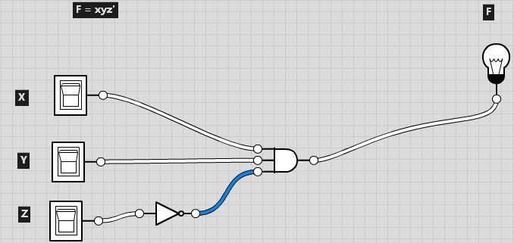

1. F = x + y’z

|  |  |  |  |
| --- | --- | --- | --- |
| x | y | z | F |
| 0 | 0 | 0 | 0 |
| 0 | 0 | 1 | 1 |
| 0 | 1 | 0 | 0 |
| 0 | 1 | 1 | 0 |
| 1 | 0 | 0 | 1 |
| 1 | 0 | 1 | 1 |
| 1 | 1 | 0 | 1 |
| 1 | 1 | 1 | 1 |



1. F = x’y’z + x’yz + xy’

|  |  |  |  |
| --- | --- | --- | --- |
| x | y | z | F |
| 0 | 0 | 0 | 0 |
| 0 | 0 | 1 | 1 |
| 0 | 1 | 0 | 0 |
| 0 | 1 | 1 | 1 |
| 1 | 0 | 0 | 1 |
| 1 | 0 | 1 | 1 |
| 1 | 1 | 0 | 0 |
| 1 | 1 | 1 | 0 |

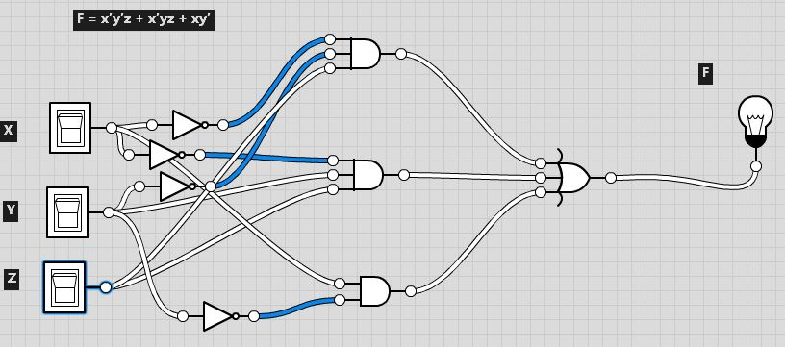

1. F = xy’ + x’z

|  |  |  |  |
| --- | --- | --- | --- |
| x | y | z | F |
| 0 | 0 | 0 | 0 |
| 0 | 0 | 1 | 1 |
| 0 | 1 | 0 | 0 |
| 0 | 1 | 1 | 1 |
| 1 | 0 | 0 | 1 |
| 1 | 0 | 1 | 1 |
| 1 | 1 | 0 | 0 |
| 1 | 1 | 1 | 0 |



B. Using a real world situation (rules for a Game, Decision Tree, Graduation

Requirements, Traffic Rules . . .) Create a Binary Equation and Truth Table. Equation

must have at least 3 terms and use both AND and OR.

History class requirement for senior year

X= World history Y= United States History Z= A history elective W= Ap European history

|  |  |  |  |  |
| --- | --- | --- | --- | --- |
| W | X | Y | Z | F |
| 0 | 0 | 0 | 0 | 0 |
| 0 | 0 | 0 | 1 | 0 |
| 0 | 0 | 1 | 0 | 0 |
| 0 | 0 | 1 | 1 | 0 |
| 0 | 1 | 0 | 0 | 0 |
| 0 | 1 | 0 | 1 | 0 |
| 0 | 1 | 1 | 0 | 0 |
| 0 | 1 | 1 | 1 | 1 |
| 1 | 0 | 0 | 0 | 0 |
| 1 | 0 | 0 | 1 | 0 |
| 1 | 0 | 1 | 0 | 0 |
| 1 | 0 | 1 | 1 | 0 |
| 1 | 1 | 0 | 0 | 0 |
| 1 | 1 | 0 | 1 | 0 |
| 1 | 1 | 1 | 0 | 1 |
| 1 | 1 | 1 | 1 | 1 |

F= XY(Z+W) or F=XYZ+XYW

